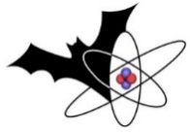
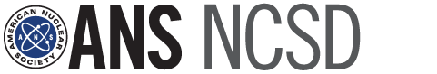

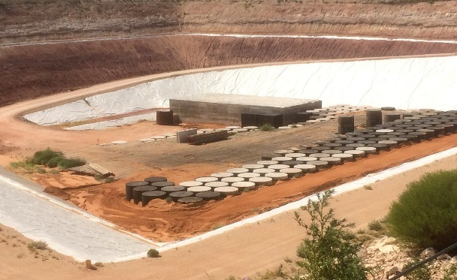
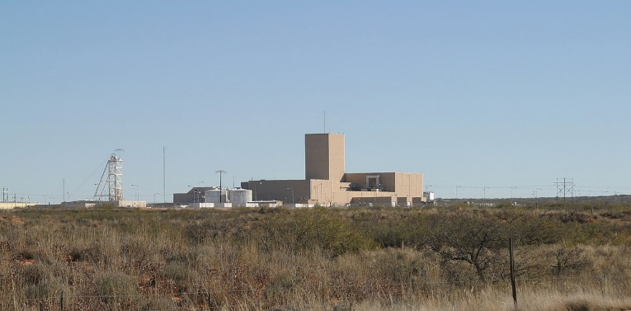

  - 2017 Nuclear Criticality Safety Division Topical meeting

September 10-15, CARLSBAD, NM
Criticality Safety – pushing boundaries by modernizing and integrating data, methods, and regulations

APPLICATION

FOR GRADUATE STUDENTS / POST-DOCS
Three to four graduate students / post-docs who will be attending the meeting will be selected, and their participation costs will be reimbursed (up to $1,700, and presentation of receipts).
Note that applicants are responsible for their registration and their own travel arrangements.

Proud Sponsors:
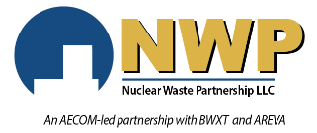
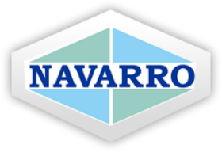
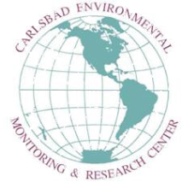

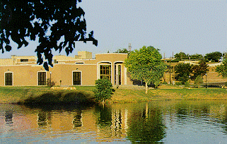
Deadlines:

July 13, 2017: Submission of Application

July 15, 2017: Notification to selected candidates

Instructions:
Please fill the form below (the more details you provide, the easier we can assess),
save and send, by July 13, to:
Dr. Anderson Ward, 2017 NCSD Topical Meeting Student Program Chair,
Anderson.Ward@cbfo.doe.gov
Name:
School/University:
Email:
Recommended by (optional):
Current area of study/work:
Your involvement in ANS NCSD:

